Population Model Version 3 – Documentation

The aim of this document is to inform of the overall structuring of the model, the finer details and reasoning of the implementation where it may be otherwise illusive. It is expected that this document will be read alongside the project’s Javadoc and in the case of the finer details the inline comments and source code.

1 Model Overview 2

1.1 Data Input 2

1.2 Desired Population Composition 3

1.3 Generating the Simulated Population 3

1.4 Deriving Generated Population Composition 3

1.5 Statistical Comparison of Desired and Generated Populations 4

1.6 Tables – Population Data Representation 4

2 Simulation Design 5

2.1 Terminology 5

2.2 Seed Population 5

2.2.1 Conceptual Approach 6

2.2.2 Algorithmic integration 9

2.3 Birth 9

2.4 Multiple Births (twins, triplets, etc.) 9

2.5 Partnering 9

2.6 Separation 9

2.7 Death 9

3 Implementation Details 10

4 References 11

5 Appendix 12

5.1 Information in the Statutory records for Scotland 12

5.1.1 For Births 12

5.1.2 For Marriages 12

5.1.3 For Deaths 13

# Model Overview

The key focus of this model was to focus on a structure that would be able to take input in the form of summative information about the desired composition of the generated population and then to be able to make a statistical assertion regarding the similarity of the desired and the generated population. The need for a robust statistical comparative approach was deemed necessary due to the complexity of modelling a population across many variables and summative statistics, as was evidenced in the earlier versions of our population models.



Detailed below is what is involved and expected in each stage of the model.

## Data Input

Associated classes: **DesiredPopulationConpositionFactory, DesiredPopulationComposition**

Inputted data represents the rate at which modelled events occur at in the desired population. The data can be provided for every year in the population. If not, then the approach by which data will be imputed is detailed in section [TO IMPLEMENT].

The events modelled are:

* Birth – specifically the proportion of females of a given age in a given year that give birth.
* Marriage – specifically the proportion of males of a given age marrying females of a given age in a given year.
* Death – specifically the proportion of people (divided by gender) of a given age that will die within one year from the given year.

In the case of birth and death the data form used is often described as a Lifetable or as the Kaplan-Meier method in the domain of demography and actuarial sciences.

The input and construction of this data into a collection is handled by the DesiredPopulationCompositionFactory and results in a DesiredPopulationComposition object.

## Desired Population Composition

Associated Classes: **DesiredPopulationComposition, EventRateTables, StatisticalTables, PopulationInformationCollection**

Once data has been placed into a DesiredPopulationComposition, the model now has an understanding of what characteristics the user wishes for the end population to exhibit. Access to the information identifying the rates and proportions at which events are desired to occur in the population is provided through the interface EventRateTables. The rate data that is returned is expressed in the form of Tables, details of which are explained in section 1.6 and for the association of Table formats with data types the JavaDoc is the best and persistently updated source.

The information regarding the desired information is also needed by our statistical approaches and often in specific formats, the StatisticalTables interface makes provision for this and is implemented by the GeneratedPopulationComposition class as well.

## Generating the Simulated Population

Associated Classes: **Population, DesiredPopulationComposition, EventRateTables, IPopulation, IPerson, IPartnership**

In the process of generating the simulated population calls are made to the DesiredPopulationComposition to access data about the rates and proportions that modelled events should occur to the generated population.

The simulation approach is to be able to define cohorts within each year of the simulation and then to apply to each cohort the number of events as specified by the DesiredPopulationComposition.

## Deriving Generated Population Composition

Associated classes: **Population, GeneratedPopulationCompositionFactory, StatisticalTables, GeneratedPopulationComposition**

Once a population has been generated we need to place it into a form that allows for comparative analysis. This is done by passing the Population to the GeneratedPopulationCompositionFactory that produces a GeneratedPopulationComposition object. The GeneratedPopulationComposition also implements the StatisticalTables interface like the DesiredPopulationComposition class and thus allows for statistical comparisons of the two to be made, this is outlined in section 1.5.

The process of creating the GeneratedPopulationComposition involves processing the generated population so as to create the summative data of the population as required by the StatisticalTables interface.

## Statistical Comparison of Desired and Generated Populations

Associated classes: **ComparativeAnalysis, KaplanMeierAnalysis, StatisticalTables, DesiredPopulationComposition, GeneratedPopulationComposition**

As detailed in the overview, the aim for the model is that the generated population can be statistically verified as being significantly similar to the desired population.

The ComparativeAnalysis class coordinates the retrieval of the required data from the different population composition classes and then makes use of the assisting statistical classes to compare the collected data.

For strict event based data that can be expressed in survivor table is compared using the Kaplan Meier method (Tierney et al., 2007; Kleinbaum & Klein, 2006). The method compares the two survival curves and can be used to calculate a Hazard Ratio which compares the level of risk in the desired and generated populations which can be used to indicate the similarity of the two populations.

## Tables – Population Data Representation

Associated classes: **Table, OneWayTable, TwoWayTable**

The handling of data in the model is a regular occurrence, therefore a table approach is provided. The tables can have either one or two look up variables. For example, in terms of death rates for men there is one look up variable, this being age. Whereas for marriage there are two look up variables, these been the age of the male and the age of the female. Example of the structuring of these tables and example tables for each event can be seen in the JavaDoc in the StatisticalTables interface.

# Simulation Design

## Terminology

To save confusion a set of definitions are set out here for any words to which ***emphasis*** is placed upon in this document.

***population*** – the set of individuals who are alive in the simulation at an instant in time, this also implies knowledge of their inter-relatedness.

***full population*** – the set of individuals who have been alive within the simulation

***T0*** - The time in the simulation from which the model is required to produce a population that has ***integrity***.

***TS*** - Where we set the very beginning of the simulation to be to ensure the population at ***T0*** has ***integrity***.

***TE*** - The end time in out population model.

***seed population*** - The population of people who will have been created and be reachable (by traversal of the population graph) at ***T0***.

***genesis population*** - The population introduced synthetically at ***TS*** (and shortly afterwards) which is then used as the population to begin the simulation with; which in turn becomes the ***seed*** ***population*** at ***T0***.

***integrity*** - a full population is considered to have integrity where all people alive at ***T0*** have all the information (both within themselves and by traversal of the population graph) to fill in the required population outputs – in the initial case these are the ***event certificates***. A consideration of what integrity requires is given in section 2.2.1.1.

***event certificates*** - The birth, marriage and death certificates that are used in Scotland/the UK to record events. And although the reality of these should not limit the extent of the population model, it is reasonably to use such to consider where we need to set ***TS*** to be for our needs. *To be clear, it is possible to set the simulation date to begin earlier to suit the usage of the system and the population simulation is foremost concerned with producing a* ***full population*** *with a set of attributes which can then be output into the form as desired by the user – in the case of the original intention for the system this was birth, marriage and death certificates as used in Scotland.*

## Seed Population

**The problem being addressed:** For the population generation project there is the need to be able to create a ***seed*** population to exist at ***T0***. This ***seed*** population needs to consist of a set of people who are capable of representing all information that will need to be expressed in the outputs of our system to give a ***full population*** with ***integrity*** between the times ***TS*** and ***TE***.

The traditional way we have gone about addressing this problem has been to step back in time from ***T0***, creating a ***genesis* *seed*** population (and create relationships between the whole population at a given instant in time for all previous times) and then beginning the simulation assuming that ***integrity*** will be reached by ***T0***. This then leads to the question of how far back we need to step from ***T0*** to be sure that the population will have ***integrity*** by ***T0*** and also how the initial ***genesis population*** should be constructed to allow for the simulation to be ran in its standard approach as early as possible – i.e. we don’t want to write a really complex separate algorithm to generate a ***genesis population*** if we can achieve the same with a couple of intelligent tweaks to the standard approach we use for the rest of the simulation .

### Conceptual Approach

#### What defines integrity for a given output format?

How we define and construct the ***genesis population***, which we begin our simulation with, effects what the ***seed population*** will look like at ***T0***. ***T0***, by definition, is the point in time from which all data that you wish to be present in your output format must be present in the simulation – i.e. the people alive at ***T0*** need to exist and have however much ancestry that your output format is able to express.

#### Our output format

For our uses where the output format is the statutory records of Scotland for birth, marriages and deaths we need for all the data that is present on those records for events occurring at ***T0*** to be represented in the dataset at ***T0***. The information found on these records can be seen in the appendix in section 5.1. Inspection of these records identify that we need to have the following information that requires information about people to whom events occurred before ***T0***. These are:

On a Birth Record occurring at ***T0***:

* surname of the child
  + - This implies the need for a father to exist to create a hereditary line
* name, surname and occupation of father
  + - This further extends the identity of the father to include a name and an occupation
    - Also, the fathers surname implies the need for the identity of a further father – the circular nature of this we will consider in the next section 2.2.1.2
* name and maiden surname of mother
  + - This implies the need for a mother to exist who has a maiden name which in turn implies the need for a father to provide a hereditary line to provide a birth/maiden surname for the mother
* date and place of the parents' marriage
  + - This requires the record of the point in time where the parents marriage occurred – **note**: it doesn’t require details on that certificate such as the maiden name of the mother of the bride therefore, we don’t need to take a further step back in time to address this.

On a Marriage Record occurring at ***T0***:

* whether parties were single, widowed or divorced
  + - This requires a knowledge of if either party has had a previous marriage, their previous spouse and their date of death and it’s proximity to the end date of the previous marriage
* names of parties
  + - This requires names and surnames of the parties as also seen in the case of parents on a Birth Record
* name, surname and occupation of fathers
* name and maiden surname of mothers
* date of birth of both parties
  + - These require the same information as would also be need for a Birth Record occurring at ***T0***.

On a Death Record occurring at ***T0***:

* name, surname and occupation of father
  + Again, this implies the need for a father to exist to create a hereditary line
* name and maiden surname of mother
  + Again, this implies the need for a mother to exist who has a maiden name which in turn implies the need for a father to provide a hereditary line to provide a birth/maiden surname for the mother

#### How far back to go?

Given the details specified for our output format as shown in section 2.2.1.2 we can consider how far back it is necessary to begin, assuming we will allow for the population to run organically from ***TS***.

If we consider what information we need to know for each generation

// UPTO HERE

The 'Magic Children' approach is based on the understanding that there are several facets to this problem that needs to be addressed in the design of the algorithm. These are:

* The first child born after ***Ts*** must not have any older sibling
  + If such is not the case then we need further mechanisms to retroactively create family size and birth order information for the mother in question
* We should not have to explicitly handle the partnering together of mothers and fathers and the attachment of children to these 'families' within a large population who have been statically generated.
  + Doing this, again, requires further mechanisms beyond the core simulation model we are designing.
  + Also, this is the hard problem we're trying to solve for the whole larger population - therefore to assume we can easily achieve this in the initial **genesis population** implies we should just do this for the whole population at ***TE***.

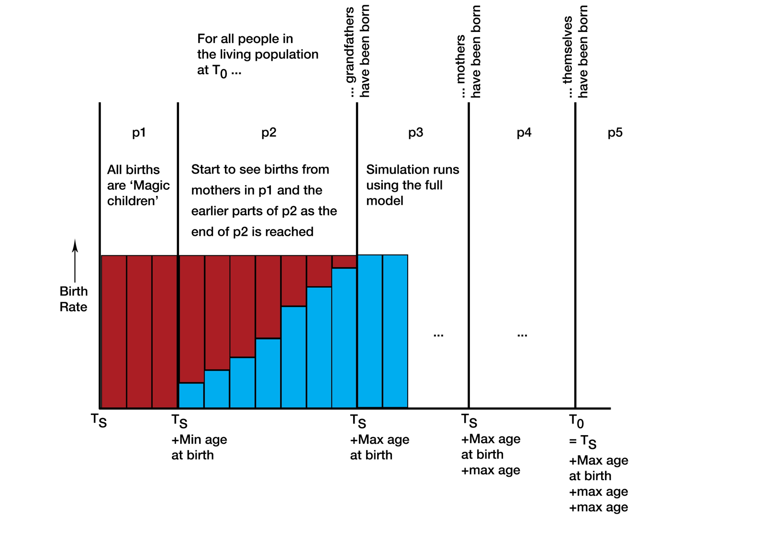

The above diagram outlines the 'Magic Children' approach to the model. The y-axis shows the birth rate for each time period, and as the x-axis, representative of time, is parameterised by population variables the axis itself is not linear in this graph.

**How far back to go?**

The premise that the people living at ***T0*** must have grandparents allows for us to decide the earliest year that it is possible for somebody to be born where all we know of them is their surname i.e. that they are the grandfathers of the population at ***T0*** and therefore we have no need to know who there parents or even siblings are.

There is a case to be made that the siblings of these grandfathers could be implied by shared surnames, however the persistence of such in our data set would only be by brothers of these grandfathers (as the maiden names of the grandmothers will fail to persist due to the information being stored in our records). However for our intending end usage in the testing of linkage these surnames at such longitudinal distance would be discounted due to the likeliness of them being the same name rather than a shared family name - however if we decided such information was useful then it would be possible to set an earlier value for ***TS*** to give more validity to any shared names at the among the population of 'magic children' existing in the early stages of the simulation.

As we have decided (for our uses) that the grandparents must make up the population at ***TS*** we can now consider what we need to know about these individuals. The data that is persisted onto the ***event certificates*** means that of the grandparents generation the surname of the male (in truth his existence within the data structure which identifies a family line to which a surname will be applied after the simulation) is what is of importance to the wider simulation. Also, if we are to run the simulation 'normally' then we also need to have the information about these individuals to allow us to enact births - therefore ages of both males and females and any other children they have needs to be held to be used in the local simulation.

The information pertaining to any other children to be used in the local simulation takes us back to the earlier noted facet that we intend not to handle *the attachment of children to ... 'families' within a large population who have been statically generated.*

Therefore we need an approach that allows us, in the case of the grandparents generation, to only have births (creating the parent generation) for which we have controlled the birth of every firstborn and then subsequent child. If we consider that that gap between mother and offspring is a given value - namely **min age at birth** - then any people at existence the time we control the first birth cannot be older than min age at birth, else we would have to assume that an older individual in the population would be there parent - thus then needing us to handle *attachment of children ... in a statically generated [population].*

**How to begin?**

We now have a concept that for the initial people in our population we only need to for them to mark the beginning of a family line and for us to be able to control all births that they are a parent in. This allows for us to imagine that these individuals could by spawned in the early stages of our simulation and then be used to generate the parent generations and the generation who are alive at ***TS*** and thus giving that generation its ***integrity.*** Let us term these individuals spawned without lineage as **Magic Children**.

This introduces the question of how many magic children should be created. This requires us to consider the birth rate and death rates the population will be exposed to between ***T0*** and ***TS***, from this we can calculate the population growth rate (PGR). Using the PGR and the target population size at ***TS*** we can then calculate the expected population size at ***T0+max age***. This tells us the size of the population the birth cohort since ***T0*** has lead to. We can consider the size of the population here in life table notation as **Σl(x)** (for values of x from 0 to max age) and from which we can calculate **l(0)** - namely the number of people born in the first year following ***T0***.

**Transition of the birthing approach**

From the off when these magic children are spawned we begin to run the core simulation model - checking for people to give birth, finding fathers, geographical movement, enforcing death. Obviously until any of the magic children reach the minimum age at birth there will not be any births. In this stage of the simulation we will keep track of how many natural births there are each year and for the calculated shortfall (considering the target PGR in this period and the death rate occurring in the simulation) the correct number of Magic Children will be spawned into the population each year. Up until time ***T0+min age at birth*** the births will be made up wholly of magic children but between then and ***T0+max age at birth*** the number of natural births will increase meaning the shortfall decreases and thus the number of Magic Children being spawned tapers away until in the year following ***T0+max age at birth*** it is zero. From here on the core simulation runs without any correction from the Magic Children adjustment.

**Other approaches**

**Statically generated genesis populations**

As has been touched upon above, approaches that are based upon a full statistically generated population being created at ***T0*** then require us to *explicitly handle the partnering together of mothers and fathers and the attachment of children to these 'families'*. For this reason such an approach seems unlikely to be successful without considerable work on approaches to form 'families' in a statically generated population.

### Algorithmic integration

## Birth

## Multiple Births (twins, triplets, etc.)

## Partnering

## Separation

## Death

# Implementation Details

# References

Kleinbaum, D. G., & Klein, M. (2006). *Survival analysis: a self-learning text*. Springer Science & Business Media.

Tierney, J. F., Stewart, L. A., Ghersi, D., Burdett, S., & Sydes, M. R. (2007). Practical methods for incorporating summary time-to-event data into meta-analysis. *Trials*, *8*(1), 16.

# Appendix

## Information in the Statutory records for Scotland

### For Births

*Information taken from:* [*http://www.nrscotland.gov.uk/research/guides/statutory-registers/births*](http://www.nrscotland.gov.uk/research/guides/statutory-registers/births)

Most records include:

* forename of child
* surname of the child
* where born
* date of birth
* time of birth
* sex
* name, surname and occupation of father
* name and maiden surname of mother
* date and place of the parents' marriage
* signature, address (if not the place of birth) and relation of informant
* signature of registrar

For 1855 only information about:

* the parents’ other children (living or dead)
* the ages and birthplaces of both parents was included.

### For Marriages

*Information taken from:* [*http://www.nrscotland.gov.uk/research/guides/statutory-registers/marriages*](http://www.nrscotland.gov.uk/research/guides/statutory-registers/marriages)

Most records include:

* when, where and how married
* names of parties
* occupation of bride and groom
* whether parties were single, widowed or divorced
* their ages
* addresses of bride and groom
* name, surname and occupation of fathers
* name and maiden surname of mothers
* signature of witnesses
* where the marriage was registered and signature of registrar

In 1855 entries you will also find information about:

* the place and date of birth of both parties
* the number of any children by former marriages (whether living or dead)
* the number of previous marriages (if any)

From 1965 onwards:

* date of birth of both parties
* addresses of witnesses
* occupations of the mothers of the bride and groom has been recorded.

### For Deaths

*Information taken from:* [*http://www.nrscotland.gov.uk/research/guides/statutory-registers/marriages*](http://www.nrscotland.gov.uk/research/guides/statutory-registers/marriages)

Most records include:

* forename of deceased
* surname of deceased
* occupation
* marital status
* if married the name of the spouse
* when and where died
* sex
* age
* name, surname and occupation of father
* name and maiden surname of mother
* if parents are deceased
* cause of death
* signature, address (if not where death occurred) and relation of informant
* where and when the death was registered and the signature of registrar.

For 1855 only the following information was included:

* the names and ages of all children of the deceased (whether living or dead)
* the place of burial and the undertaker involved
* the date and place of birth of the deceased
* how long they had been in the district.

From 1965 onwards:

* the occupation of the spouse (and later civil partner)
* the occupation of the mother of the deceased